Once Upon a Time
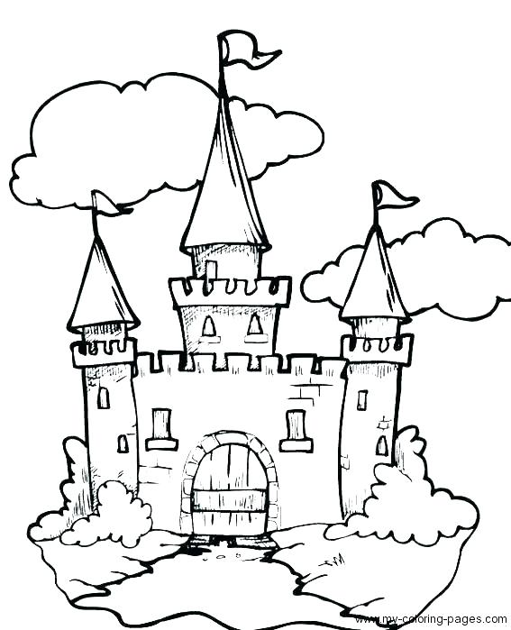

Characters:
Narrator
Princess/Prince
King/Queen
Knight(s) both male and female
Witch(es)

Setting: A Royal Castle

*Anything written in italics is a stage direction.

** Depending on how many students you have playing each role you can break the lines up or have one person do the whole thing. Adjust language if necessary.

Narrator: Once upon a time in a far-off land, there lived a royal family. (Kings, queens, princes and princess come on stage)

Kings & Queens: Oh, how happy we are to rule over the great land of Frannsylvania! We are good and just rulers and all the people in our kingdom love us.

Princesses & Princes (or both): I am young and beautiful, I have everything I could ever wish for and yet, I am sooo bored. (pouting) I dream of one day leaving this castle.
They exit

Narrator: Meanwhile, elsewhere in the kingdom there was an evil witch who wanted to find a way to get rid of the Prince and Princess so that there would be no heirs to the royal throne.

Witch enters, stirring a cauldron in her house. Knights enter and listen to the witch sneakily from the side of the stage.

Witch: Hehehe! I am making a magic potion that will turn the princes and princesses into frogs, I will pretend to be a nice old person and slip the potion into their drink at the next ball.

Narrator: What the witch did not know was that there were strong knights just outside her kitchen window listening to her make her evil plan.

Witch exits.

Knights: Oh no! I must stop the witch’s evil plan!

The knights mount their horses and ride off stage.

Narrator: Two weeks later at the royal ball the royal family was dancing and having a great time.

The kings, queens, princes and princesses enter dancing.

Kings & Queens: There is nothing like a royal ball to get your boogies out. They do the Macarena.

Princes & Princesses: This ball is so boring.

Narrator: Little did they know all that would soon change...

The witch enters without her witch’s hat. She is disguised as an old person.

Witch: Hello Princes and Princesses, what a lovely ball this is. Can I offer you some of my homemade apple juice to say thank you for having me? She holds up a bottle of apple juice (this can be mimed).

Princes and Princesses: Yes, thank you, that is very nice of you.

Just as the princes and princesses start to fill their cups with the witch’s poison apple juice, the knight bursts in.

Knights: STOOOOPPPP!!!!!!!!! Don’t drink that. It is poison!

Kings, Queens, Princes & Princesses: What!?!?

Knights: She is not really an old person. She is a witch and that is an evil potion! I saw them making it the other day as I was riding through the forest.

King & Queen: Thank you so much for warning us and saving our children, brave knight. How can we ever repay you?

Knights: How about your children’s hands in marriage?

Narrator: The king and queen agreed that those of their children that wished to marry, could marry the knights. All the royal weddings happened the very next day and they all lived happily ever after.

